DSAI Competency Maps
The competency maps for each level are listed below.
- DSAI L1
- DSAI L2
- DSAI L3
- DSAI L4
- Source Tables for DSAI Functional Competencies
- (links removed)
The wording in each competency map is drawn from the DSAI Functional Competency Source Tables.

How the 2025 competency maps changed from the 2022 competency maps
The updated competency maps were developed based on the following principle considerations:
To align with the rest of WOG, it adopts the "functional competencies" of the WoG/PSD and our People Development competency frameworks.
- The new competencies and proficiency levels are based on the WoG's technology competencies and proficiency levels, adapted to fit our context.
- Selected critical and relevant competencies from the WoG/PSD's "Data and AI" job function.
- Added elaboration for our context and defined more competencies where relevant.
To keep the granularity of the competencies reasonable for technical assessment, the working group made a conscious effort to limit the number of competencies to not more than eight (8).
- Retained the "Key Tasks and Performance Standards" to encompass other general competencies required for the job role.
- Tech Panel will assess both the "Key Tasks and Performance Standards" and the "Key Competencies".
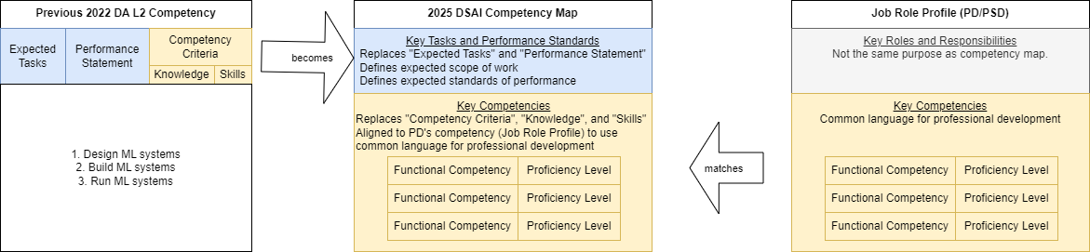

What are the selected functional competencies for DSAI
 | Competency | Definition | PSD Reference
1 | Data Project Design | Understand the data science project lifecycle. Effectively manage end-to-end data projects to meet business needs. Make sure to solve the right problems in the right way. | no exact match, but there are similarities to "Data Management & Analytics" (from "Application Management" sub-functional area)
2 | Exploratory Data Analysis | Explore, understand, and describe the dataset and its provenance. Relate the data to the problem space. Look for patterns, trends, and anomalies in data. (This step usually overlaps with "Data Preparation".) | - Exploration Analysis
3 | Data Preparation | Collect, clean, impute, validate, label, enrich, augment, featurize, and fuse/integrate datasets to enable robust analysis and/or models. | - Data Collection  - Data Quality
4 | Visualisations and Data Storytelling | Design visualizations to explain insights. Craft compelling data narratives. Contextualize the discoveries. Inform decision making. | - Data Storytelling  - Charts & Dashboards  - Visual Analytics Principles
5 | Statistical Analysis | Extract insights and inform decisions by using statistical techniques (e.g., hypothesis testing, data modeling, and significance validation) to robustly identify and validate trends, patterns, and relationships in data . | - Statistical Techniques
6 | Machine Learning | Create a train, test, and validation set. Select/design, configure, train, tune, and evaluate models to predict, describe, or recommend. Deploy and run inference at scale. Interpret results for non-technical end users.  (Click here for a longer explanation)  - Balance the trade-off of tuning machine learning models for the optimal performance vs what is realistic for productionizing the system for use  - Correctly create and use a test (and validation) set  - Model Selection: understand and select appropriate algorithms/models/ensembles which are fit for your purpose as well as your data  - Model Training: find, debug, and fix edge cases that cause training to fail or not converge  - Model Tuning: understand and tune hyperparameters efficiently  - Model Evaluation: measure and compare model performance against benchmarks, and choose the most appropriate model to deploy based on desired performance metrics  - Model Inference: deploy and run ML models at scale  - Model Interpretability: explain model outputs for non-technical users | - Machine Learning  - ML Optimization
7 | Specialisation | Mastery in specific specialisation(s) is recommended and applicable for Specialist appointments (i.e. L2 and above).  (Click here for a longer explanation)  Following PSD's lead, the definition will follow Bloom's taxonomy (removed kiwix link):  (Remember (PL1) → Understand (PL1) → Apply (PL1)→ Analyze (PL2) → Evaluate (PL2/3)→ Create (PL3/4).  Examples (this list is non-exhaustive):  - In the area of Text: NLP, MT, LLMs, etc.  - In the area of Media - Images / Video / Audio: OCR, CV, GANs/diffusion, face ID, video analytics, STT, speaker ID, etc.  - In the area of Structured Data / Quantitative: tabular, geospatial, timeseries, metadata, etc.  - In the area of Graph: SNA, KG, etc. | no exact match

How functional competencies map to DSAI Tier Levels
 | Competency | L1 | L2 (Consultant) | L3 (STS) | L4 (LTS)
1 | Data Project Design | PL1 | PL2 | PL3
2 | Exploratory Data Analysis
3 | Data Preparation
4 | Visualisation and Data Storytelling |  | PL2
5 | Statistical Analysis |  | PL2 x 1 AND  PL1 x 1 | PL3 x 1 AND  PL1 x 1 | PL3 AND  PL2 x 1
6 | Machine Learning
7 | Specialisation | NA | PL2 x 1 specialisation | PL3 x 1 specialisation AND  PL2 x 1 specialisation | PL4 x 1 specialisation AND  PL3 x 1 specialisation

